1. 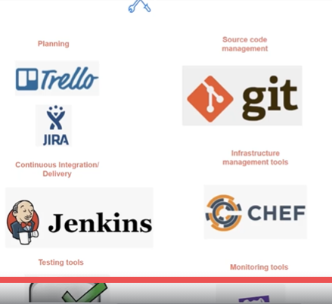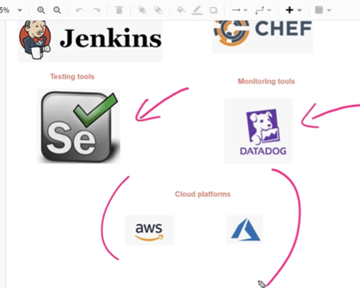
2. 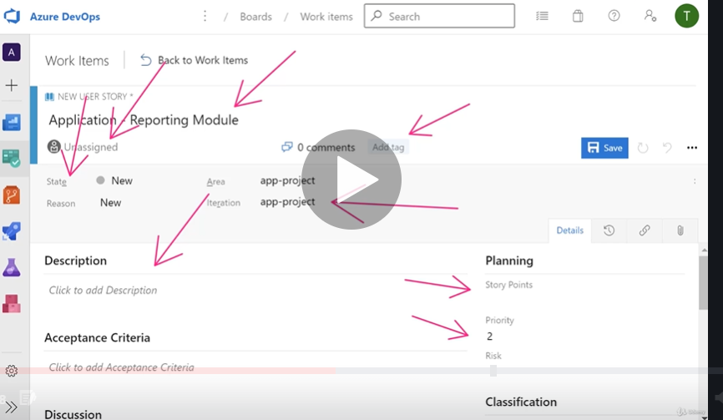
3. In this screen you will not be able to see the bugs or tasks 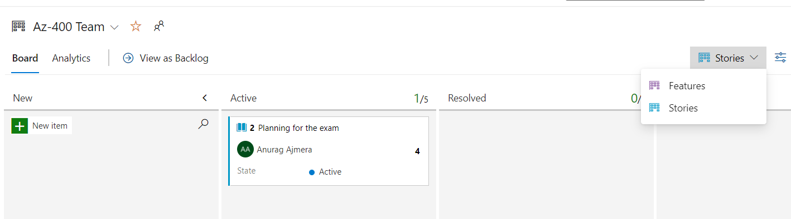
4. 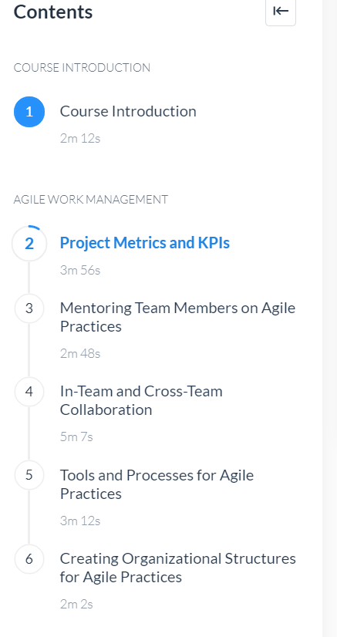
5. 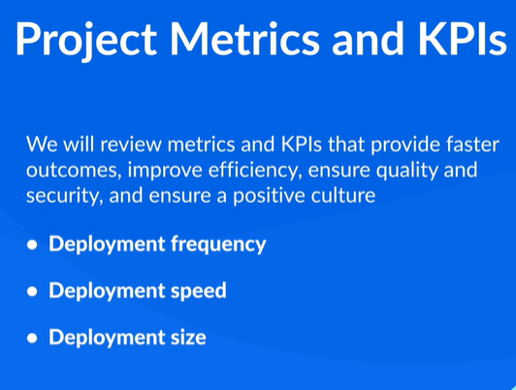
6. Deployment frequency is important because the frequency of deployments is usually a critical driver in most DevOps projects. Deployment speed is also just as important, because DevOps projects benefit when you decrease the time it takes for deployments. Deployment size refers to the number of features, stories, and bug fixes that are deployed each time
7. 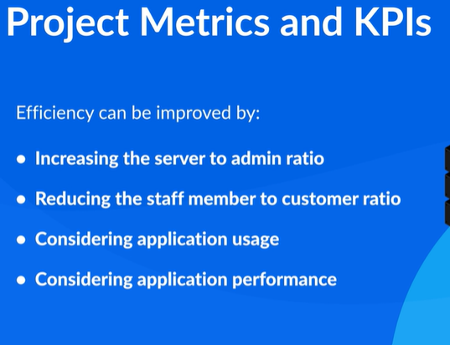
8. Efficiency can be improved by increasing the server to admin ratio, which refers to the number of administrators that are required for the number of servers that are necessary. Likewise, the staff member to customers ratio should also be kept at a minimum. This metric refers to the number of staff members that are necessary to serve a specific number of customers. Application usage and performance are two other key metrics to consider when trying to improve efficiency. While application usage refers to how busy an application is, application performance refers to how well the application is running, based on application metrics.
9. 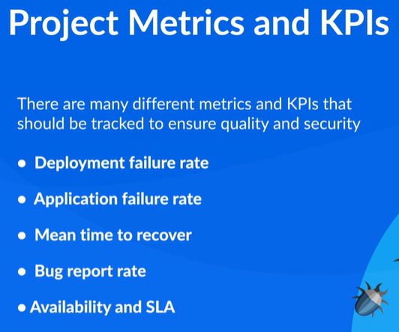
10. 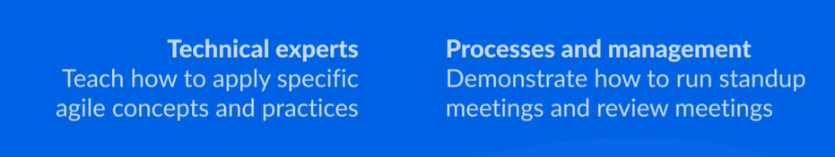
11. 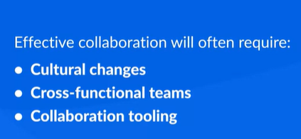
12. 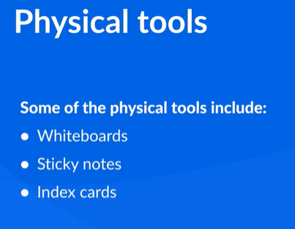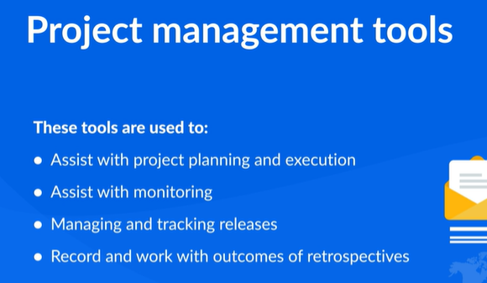
13. 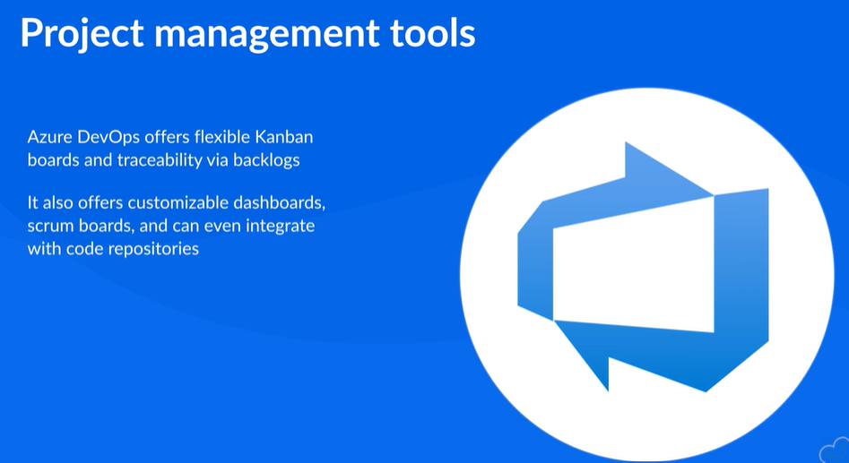
14. Azure DevOps offers flexible Kanban boards and traceability via backlogs. It also offers customizable dashboards, scrum boards, and can even integrate with code repositories. This allows you to link code changes directly to tasks and bugs.
15. While Azure DevOps is a pretty robust project management tool for agile practices, there are some other common tools available. These tools include things like **JIRA Agile, Tremolo, SprintGround,** and many, many others. Your job is to determine which project management tools work best for your agile practice.
16. 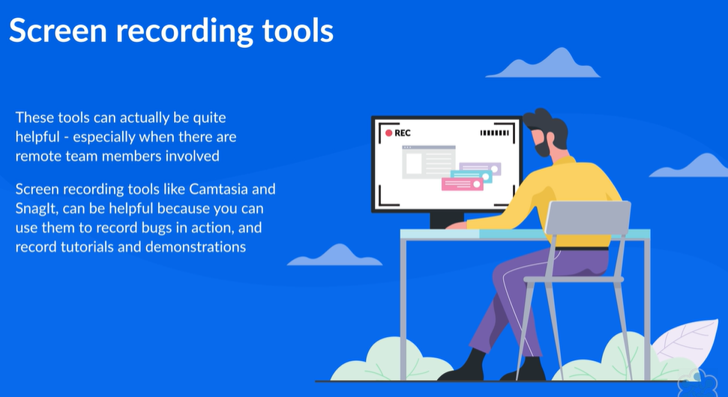
17. 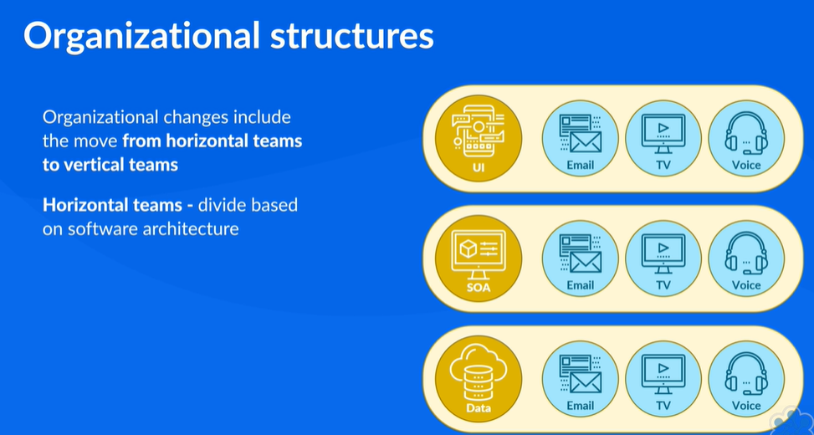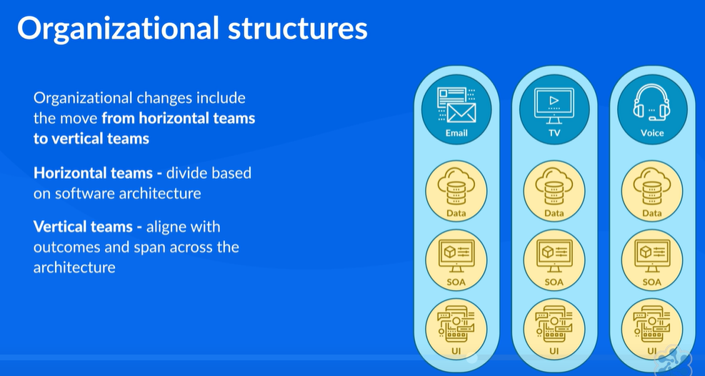
18. 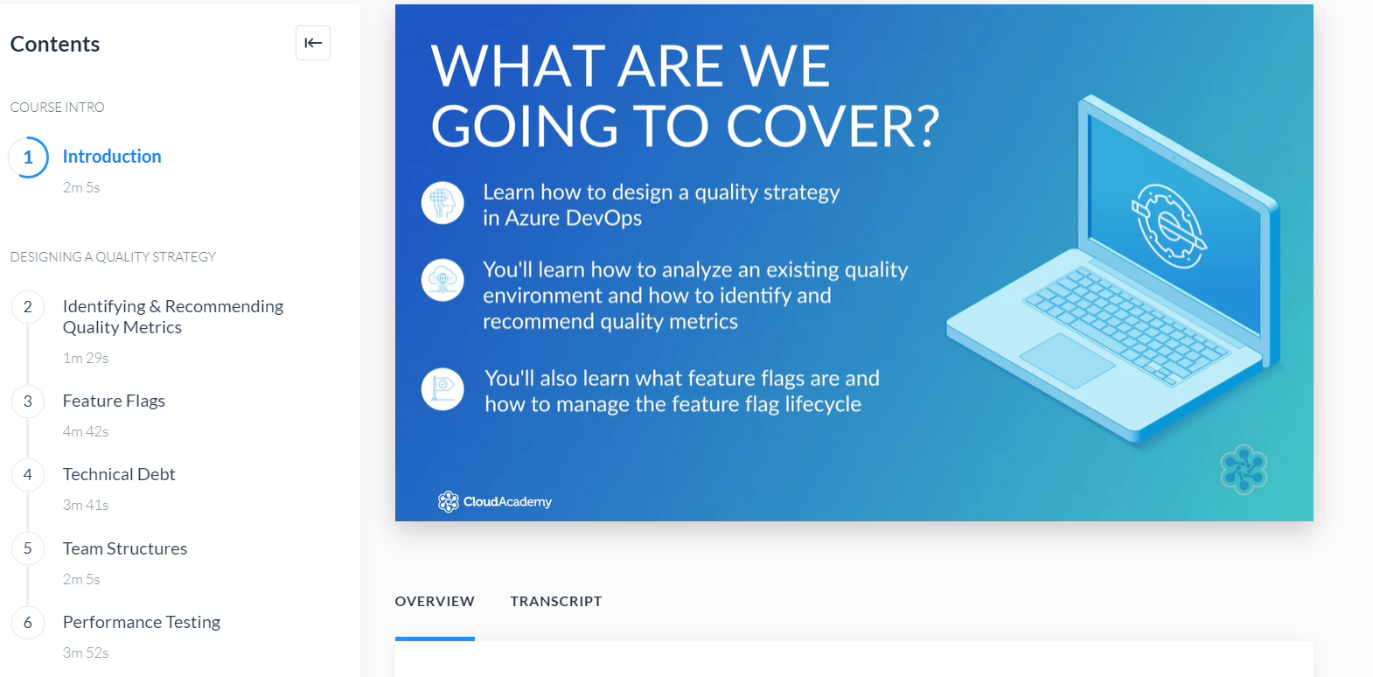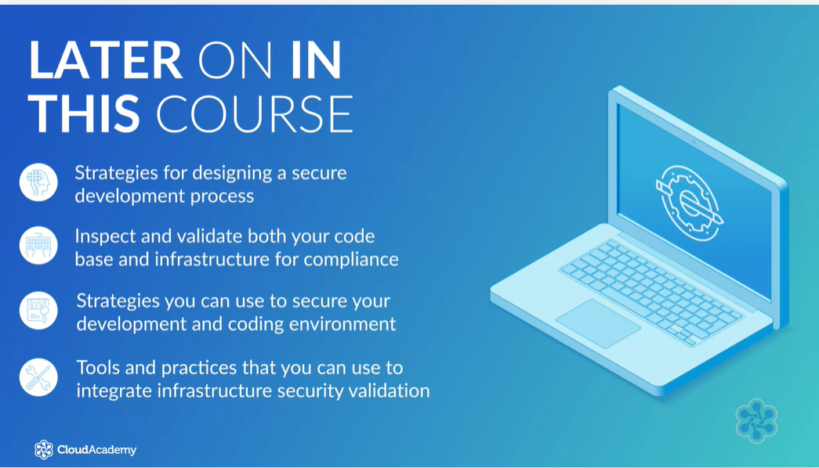
19. Azure DevOps allows organizations to deliver software faster and with higher quality. Oddly enough these two metrics are typically viewed as polar opposites. Generally speaking the faster an application is typically rolled out, the lower the quality of that app. The higher the quality of the app, the longer the development cycle. However, by leveraging Azure DevOps processes, developers can identify issues sooner which in turn usually means that they can fix them sooner.
20. Taking stock of these key metrics allows you to more easily identify and recommend quality metrics in your development environment.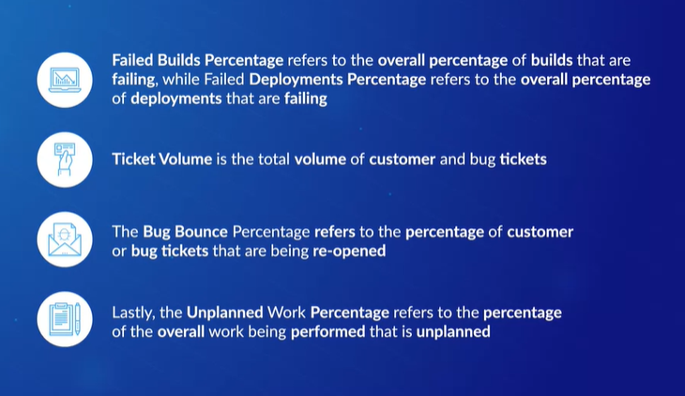
21. Feature flags are used to change how things work. Instead of making significant changes to the actual code within an app, you only need to make a small configuration change, and more often than not, this configuration change will only be necessary for a small number of users. Leveraging feature flags provides an elegant solution when you would otherwise need to deploy new code into trunk, but not yet have it functional. Feature flags are typically implemented as the value of variables which are then used to control conditional logic.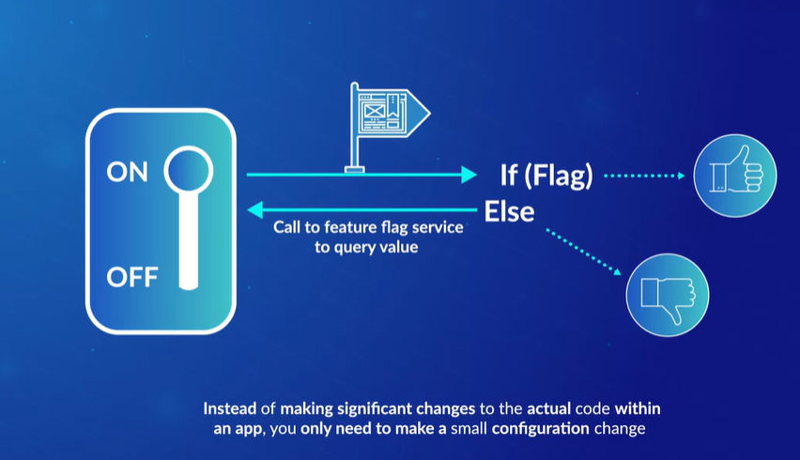
22. 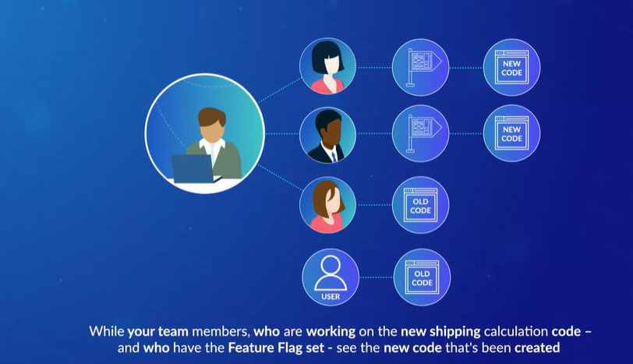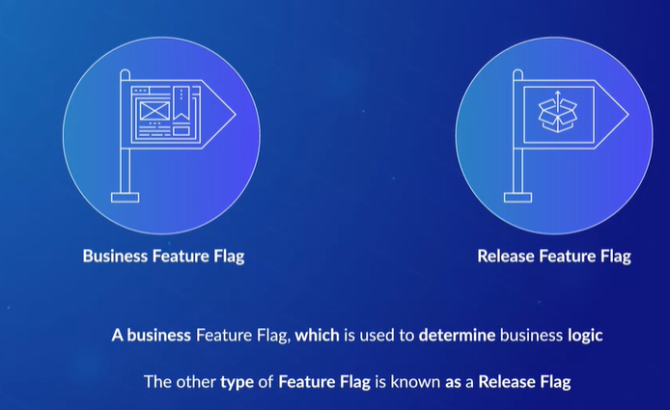
23. Now to demonstrate the use of a release flag, let's build upon our previous example. Let's assume your team has completed its work on the shipping calculation code. While you're pretty confident in your team's work you might be a little bit apprehensive about pushing this new code out to all of your users at once. In this case you'd rather push out the changes to a group of users that's better at dealing with new code and the issues that sometimes arise from that new code. This type of group consists of users that are referred to as canaries. The term canary comes from the old use of canaries in coal mines.
24. What you would do in this case is change the configuration so that your canary users also have the feature flag set. As a result they can start testing the new code as well while the original code continues to function for all other users. If things go south for the canary users you can quickly disable the flag for them so they can go back to using the original code.
25. The minute you use a feature flag for the first time, that feature flag gets added to the overall technical debt that you need to contend with. That in mind you need to realize that the longer a particular flag hangs around as part of your code, the bigger that technical debt becomes.
26. As you continue to add more and more feature flags to the code, that code becomes more and more complex. Ultimately you wind up with code that's more difficult to test than it needs to be and it's harder to maintain due to its complexity. This often makes it more difficult to troubleshoot because it becomes harder and harder to duplicate problems as part of that troubleshooting process.
27. To avoid these types of issues, you really need to remove unneeded feature flags as soon as you can
28. I should also point out that you should never repurpose feature flags. This is a big no-no because it opens you up to the possibility of using a flag for a new purpose even though that flag is still part of your code for its original purpose. This can cause all kinds of serious headaches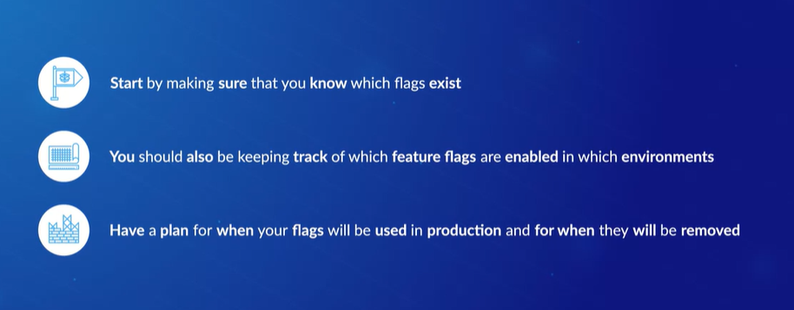
29. Technical debt refers to the future costs that will be incurred when you decide to deploy an easy solution rather than one that's grounded in best practices. it's essentially the price you pay for bypassing best practices because deploying them takes longer to complete.
30. This snowball effect isn't much different from the snowball effect that occurs when developers make decisions without any regard for the future. Just like financial debt, technical debt will snowball to the point where developers wind up spending most of their time troubleshooting problems and doing rework. This prevents them from adding much value to the project and to the organization in general
31. Increased technical debt is often blamed on tight deadlines because if a developer is forced to throw together code quickly he's often going to take shortcuts, it's only natural
32. 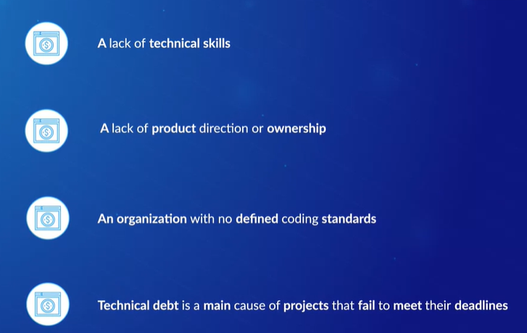
33. By building in support for things like Sonar Cloud to an Azure DevOps pipeline, you can leverage it to analyze your code. This allows you to drill down into issues that are identified. As a result, you can see what the issues are along with suggested remedies. You can even view estimates of the time that's required to apply each remedy
34. Some strategies for planning and implementing performance testing. Because users are sensitive to slow or malfunctioning applications, organizations need to ensure that they are incorporating performance testing and load testing procedures as part of the building and deployment of applications
35. it's important to understand the difference between performance testing and load testing
36. Performance testing is used to see how responsive an application is, how stable it is, and how efficiently it uses the resources that are assigned to it. While load testing is used to test an application's performance when it's run under a load
37. often than not performance testing only enters the equation after the development team is comfortable with the stability of the code. However, what should be happening is that the organization's performance testers should start running new code as soon as it's available. What this does is ensure feedback makes its way back to the developers sooner rather than later. This allows the developers to more quickly rectify issues
38. During performance testing you should be looking at how long user actions take to complete within an application
39. It's important to utilize automated testing tools to perform this testing because it's impractical to perform any sort of meaningful performance testing or to integrate within a DevOps pipeline without a suite of automation tools
40. 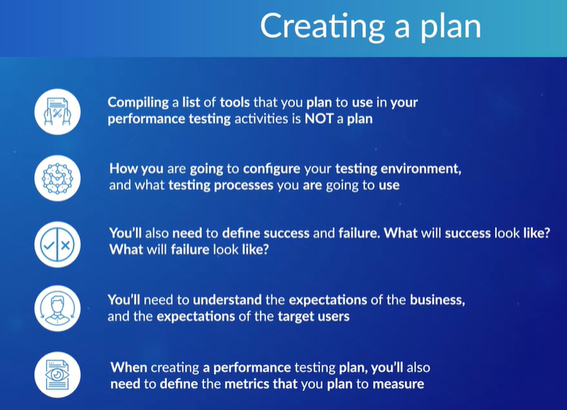
41. 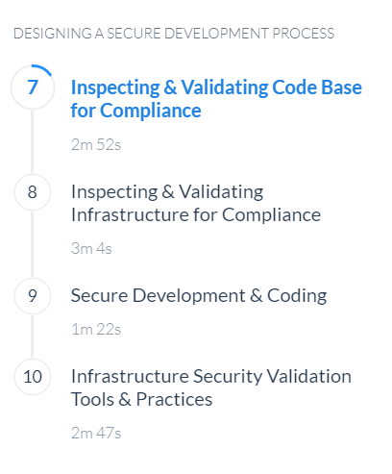
42. Using historical data archive data and logs should allow organizations to track down evidence when something has gone wrong
43. When developing secure applications it's important that you ensure that the code is created correctly and that it securely implements any features that are required. On top of that you need to ensure that the features themselves are designed with security in mind.
44. With the introduction of DevOps practices, it's now much easier for developers to integrate security testing into the app development pipeline. What this does is create an environment where security testing is part of the day-to-day delivery process rather than something that needs to be performed by security specialists after the fact.
45. 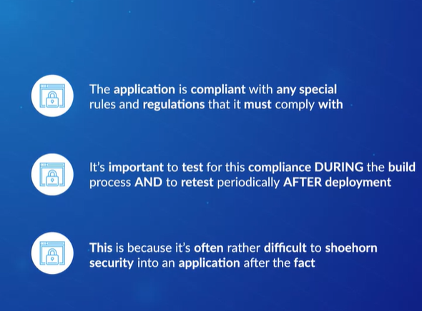
46. **Inspecting and validating Infrastructure for compliance**
47. Some time ago automating the creation of resources was done largely through procedural code that was written in languages like PowerShell. While this methodology does work, it doesn't make it easy for developers to write idempotent code which is code that produces the same outcome no matter how many times you run it
48. When PowerShell desired state configuration became available it was a huge improvement. Using DSC you could define a desired outcome instead of creating the process for achieving that outcome. DSC was a declarative way to automate the configuration and compliance of resources rather than a procedural way
49. There are now several tools available that allow you to define infrastructure as code. These tools provide lots of benefits to DevOps teams because the tools allow those DevOps teams to now build reliable environments on demand and in a repeatable way
50. 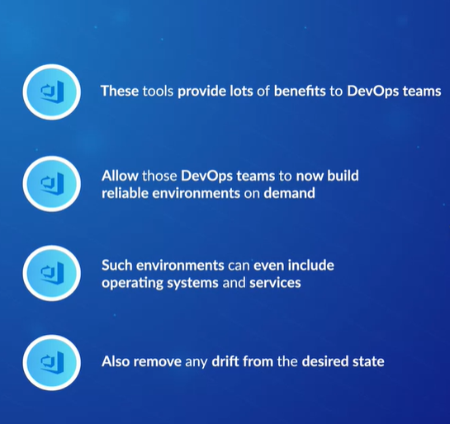
51. Now all that being said in addition to configuration of environments there is also a need to validate those environments
52. Azure Automation State Configuration is a validation tool that builds on PowerShell DSC.
53. 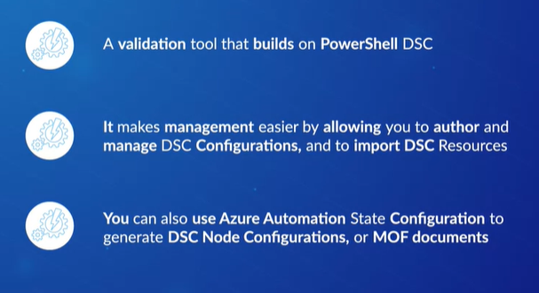
54. These DSC configurations and MOF documents are then placed on an automation server. Target nodes which can be located in the cloud or on-prem can retrieve them from the automation server. The target nodes will then automatically conform to the desired state and report their compliance state back to that automation server
55. InSpec is another validation tool
56. 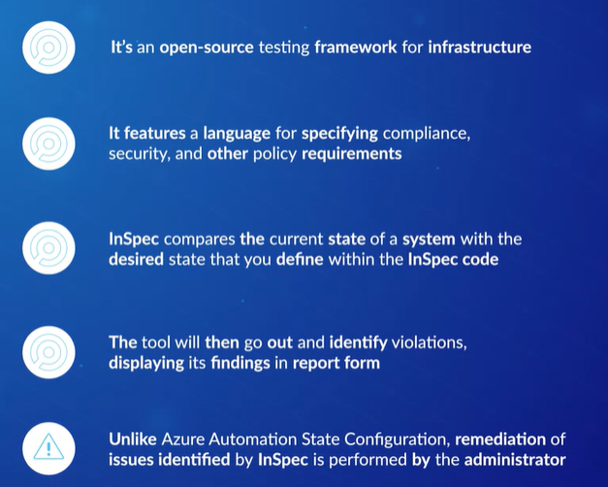
57. The Open Web Application Security Project, otherwise known as OWASP, is a global organization that focuses on improving the security of software
58. **Infrastructure Security Validation Tools & Practices**
59. When it comes to checking for vulnerabilities you can't just validate your applications. You need to also validate your infrastructure to check for vulnerabilities especially when you're leveraging public cloud resources like Azure. You need to ensure that anything you deploy in these types of public cloud environments is deployed securely
60. 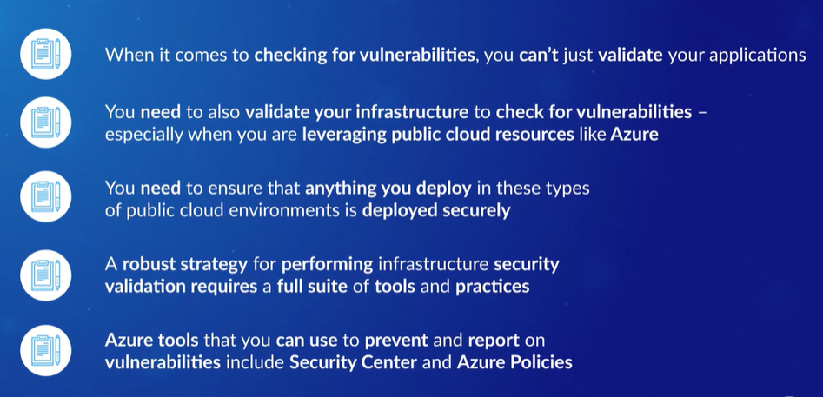
61. 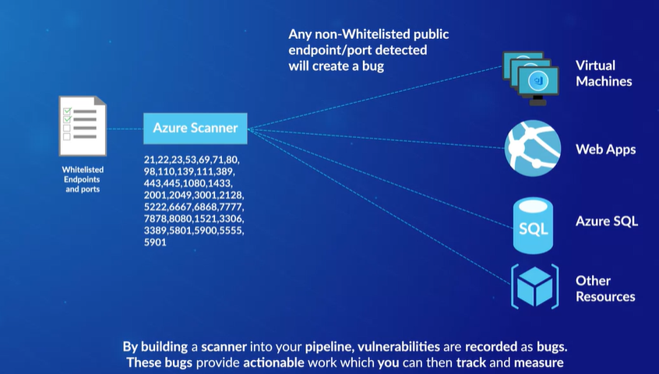
62. 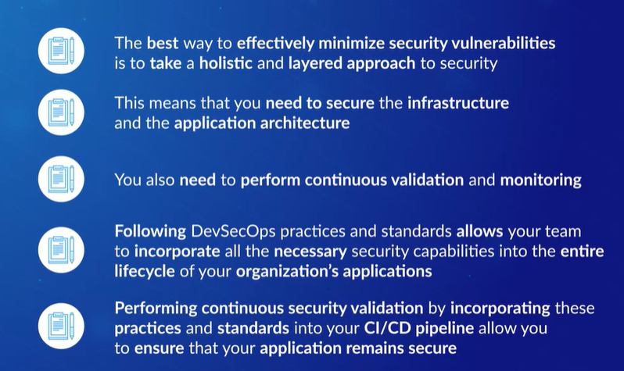
63. 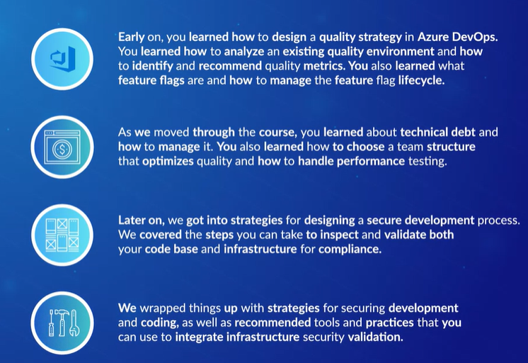

Implementing version control on Azure repos

1. 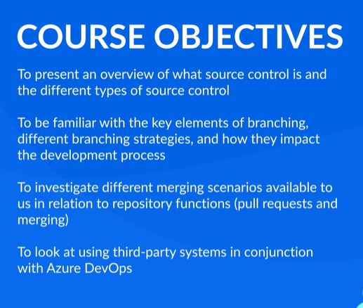
2. **Version Control**
3. 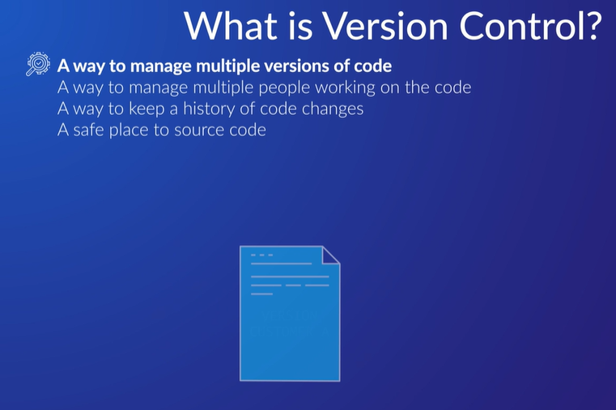
4. The main thread of the code development is called the trunk, often referred to as the master trunk, while deviations or splits from that are called branches. Because developers aren't arborists, the master trunk is often called the main branch. This technology isn't new and falls under two main types, centralized and distributed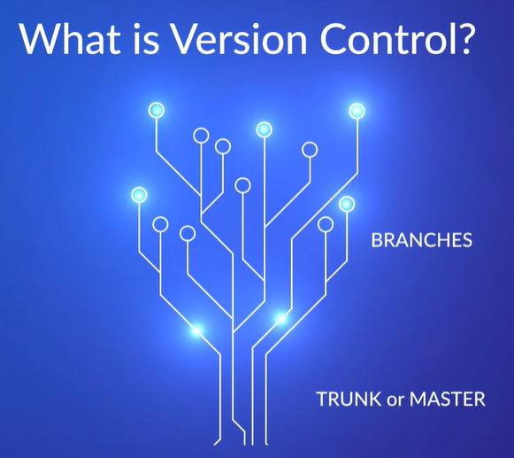
5. Centralized Version Control systems are modeled on client-server architecture, where developers check out files to work on, much like taking a book out from the library. While the file is checked out, it is locked within the Version Control system, preventing anyone else from making changes to it. This type of Version Control was very much in vogue at the beginning of the century and is represented by well known, if you are of a certain age, products, like CVS, Concurrent Versions Systems, Subversion, and Team Foundation Server, which morphed into Team Foundation Version Control, abbreviated to TFVC. One side-effect of the check-out/check-in model is behavioral. Developers tend to put off checking in until their body of work is totally complete as they don't want to break the build. This leads to large check-ins with associated conflict issues, and makes reverting or unwinding changes more difficult
6. 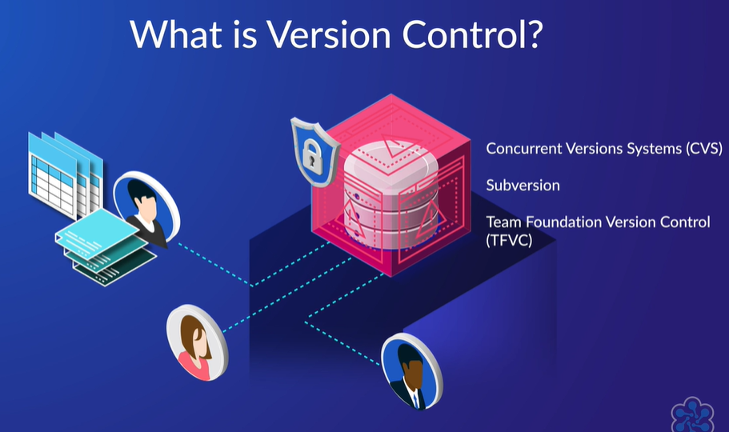
7. when we talk about distributed systems, we are invariably talking about Git. Instead of checking out and locking files from the master trunk, a developer takes a copy, called a clone, typically of the whole code base, and has it locally, where they can work on any part of it. Obviously, this is a significant advantage over the check-out/check-in model when it comes to having multiple developers working on the same code base, especially with remote workers who don't have to be connected all the time. Changes in the form of branches are typically merged back to the master trunk with what's called pull requests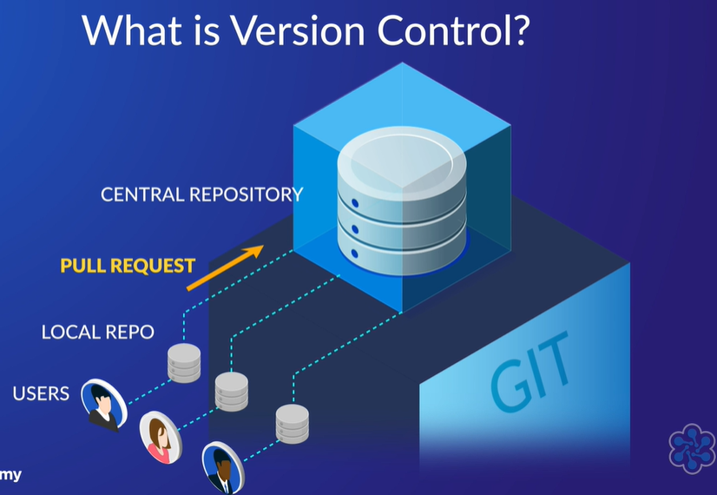
8. Azure DevOps, GitHub, and Bitbucket Cloud are all examples of cloud Git-based remote repositories. A developer with Git installed locally uses Git commands, even if that is via a graphical interface to clone, fetch, fork or pull code from the repository to their local hard drive. They work on the code making changes and saving those changes with accompanying descriptions as commits to their local Git repo. Those commits are then pushed back to the Git structure in the remote repository where they remain until they are merged back into the main trunk through a process called a pull request. A pull request is a process of code review by other developers, preferably two or more followed by a merge operation.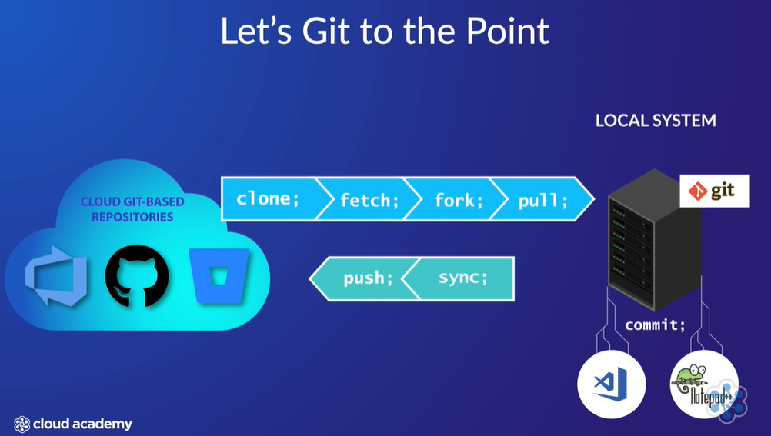
9. code flow and branching strategies
10. 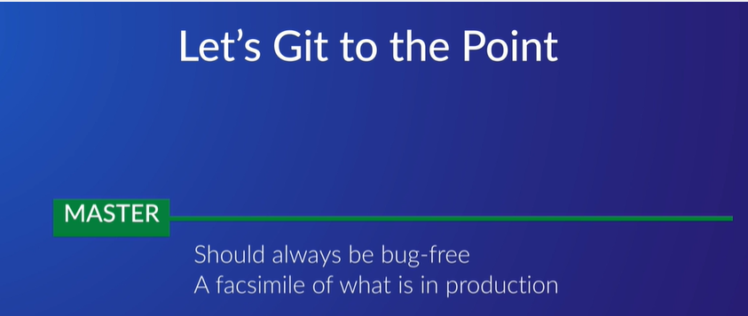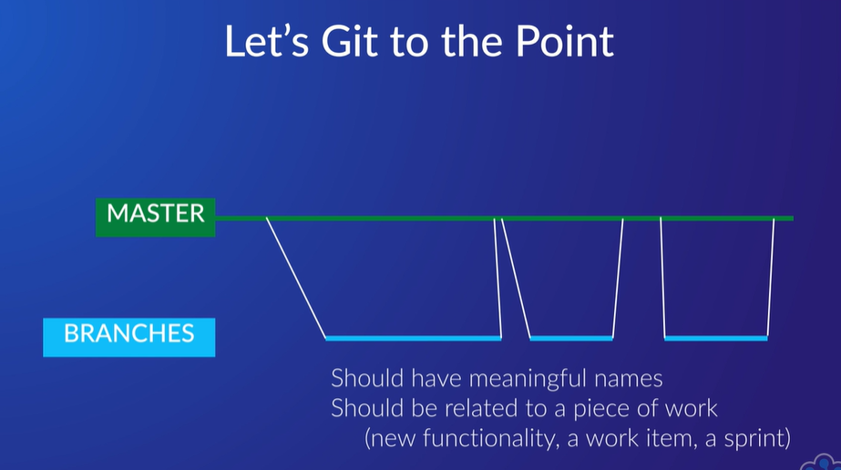
11. Commits should be frequent, relate to one code change and have an accurate and full description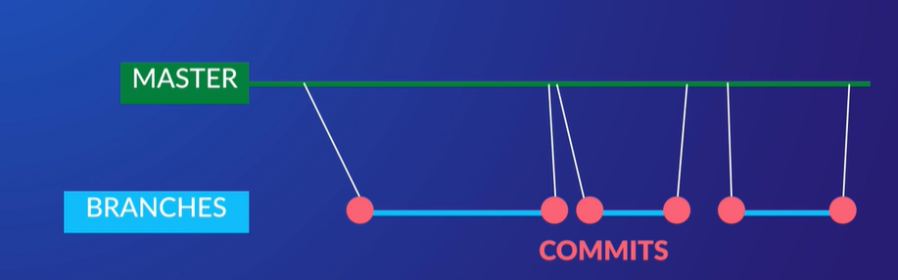
12. We want to add a customer search function to our software. First off, we need to add a branch from our known and good and stable master trunk code with a name describing what the branch is about. It's a new feature called customer search. We could just leave it at that, but in reality, the search is made up of three distinct pieces of functionality.
13. So we will split that into three branches off the customer search branch. This serves two purposes, firstly keeping each piece of work smaller and more manageable for testing, progress tracking and merging, and secondly if you want different people to work on the pieces simultaneously. Within each of these sub-branches we want work to be committed frequently and often, and I would say that what is illustrated would be the bare minimum. Committing after each piece of logic is completed helps with tracking changes, locating bugs and unwinding code changes if necessary. Each sub-branch is merged back to the customer search branch with a pull request where the code is reviewed.
14. Not to state the obvious, but reviewing a relatively small piece of code in one or a small handful of files is a relatively simple task as compared with code spread over potentially dozens of files. We've ended up with our code reviewed and successfully merged into the customer branch. This is where some of the branching strategies diverge, and I will look at why in the next section. But for simplicity sake, we can now merge our customer search branch back into the master trunk. 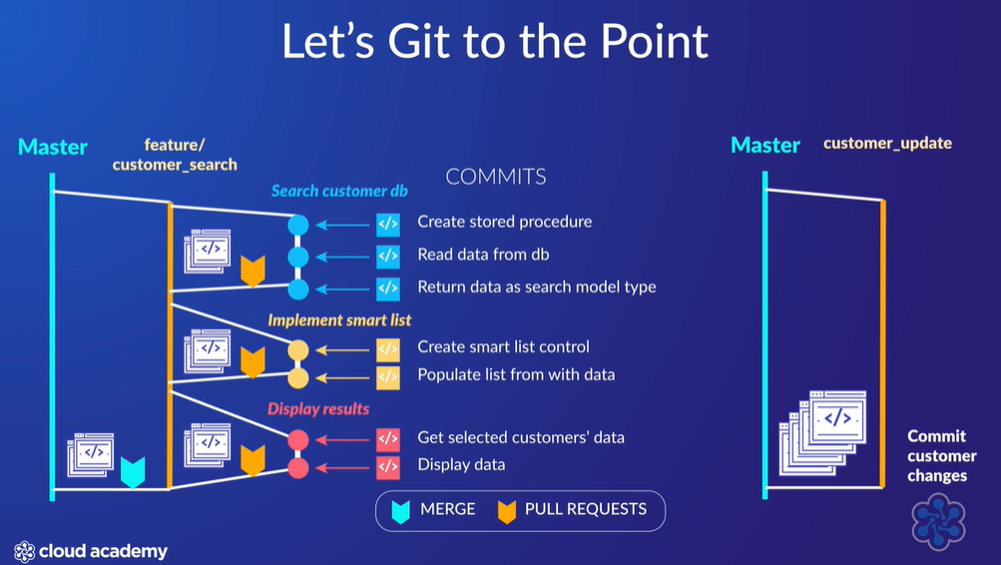
15. **Branching:**
16. Well, the cost of branching can be viewed in two ways. There is the cost of performing the branching process and there is the cost of merging the branch back into the master trunk. Creating a branch in TFVC isn't as easy as with Git, and this is mainly due to the fact that TFVC creates a physical copy of the original branch as the starting point of the new branch, whereas Git uses the most recent commit from the parent branch. It's the difference between making a physical copy of a variable, as opposed to creating a new pointer to it. The other crucial difference is that TFVC branches are always created on the server, so you have to be connected and be cognizant of branch naming and potential naming conflicts. As Git is distributed, a developer can create branches at will on their own repository and only have to be concerned when merging back to the remote branch.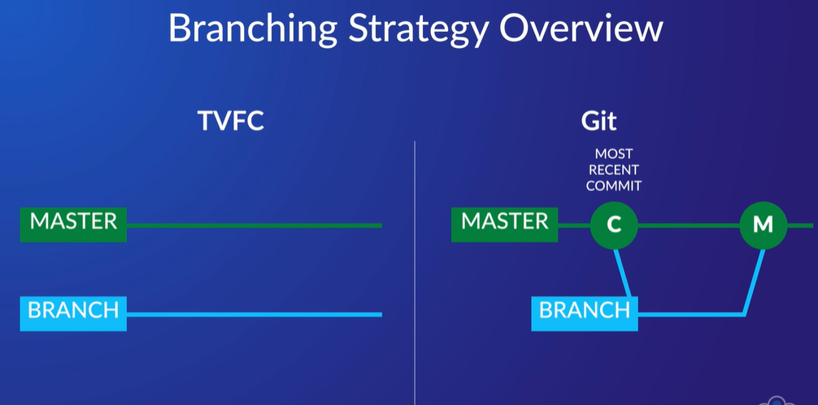
17. Everyone involved in software development will have their own horror story of branch merging, which typically revolves around sorting out code differences between two or more versions of the same file, or files. Sure, there are tools that can help with this, but it is essentially a manual process similar to untangling string.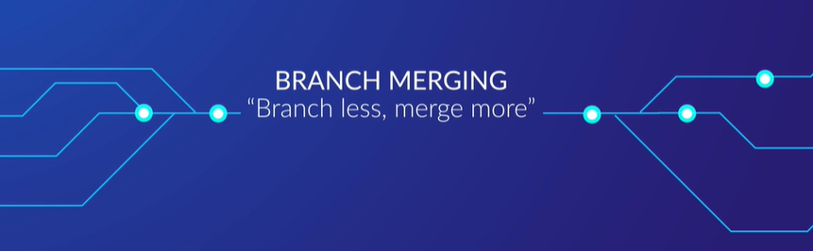
18. let's look at some generic branching scenarios starting with Main Only, which is essentially a branchless strategy, that is just the master trunk. This means all work is committed back to the main trunk or branch. The Main Only strategy has limited application. It is not suited to maintaining multiple versions and would be very difficult to manage with many developers working on multiple features. Labels can be used to mark development and release events
19. 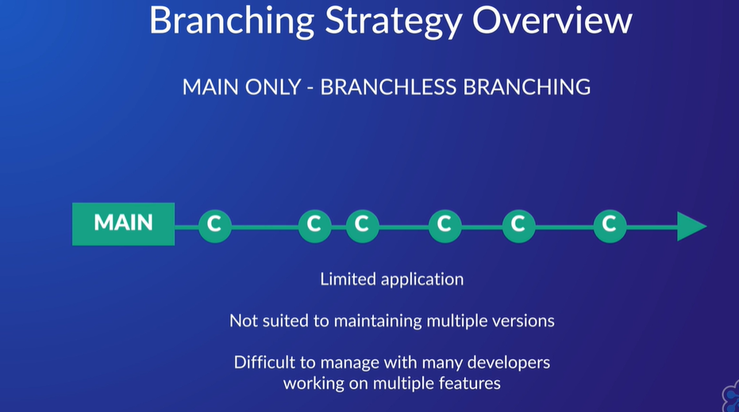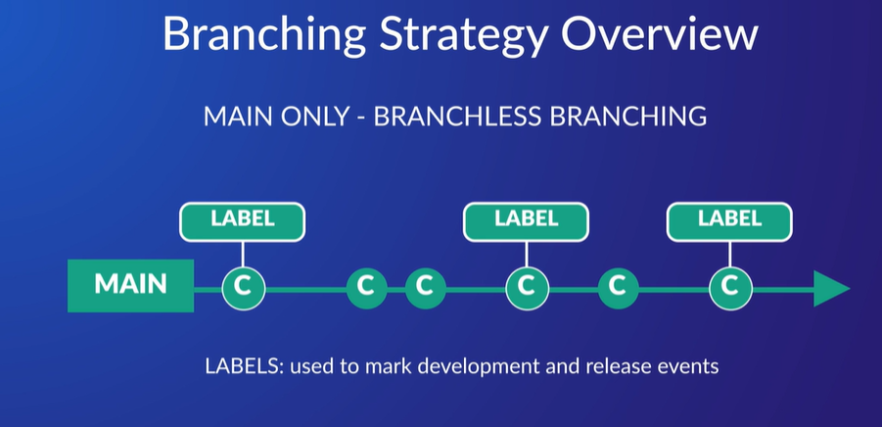
20. Development isolation is one of the strategies most people think of when talking about branching. The central tenet of branching is to maintain a stable and pristine main branch, and development isolation does this by explicitly separating all development into its own dev branch. You end up with two branches running in parallel. When a feature in the dev branch is complete, it is merged back into the main branch. When a bug is discovered in production code, it is fixed in the main branch and merged into the dev branch. It seems like a good strategy, but you've essentially ended up with two versions of the software truth, and quite some effort is required to maintain concurrency. It's definitely not unheard of for bug fixes in the main branch not to be merged into dev and then for the bug to reappear after a new dev feature is merged into main. 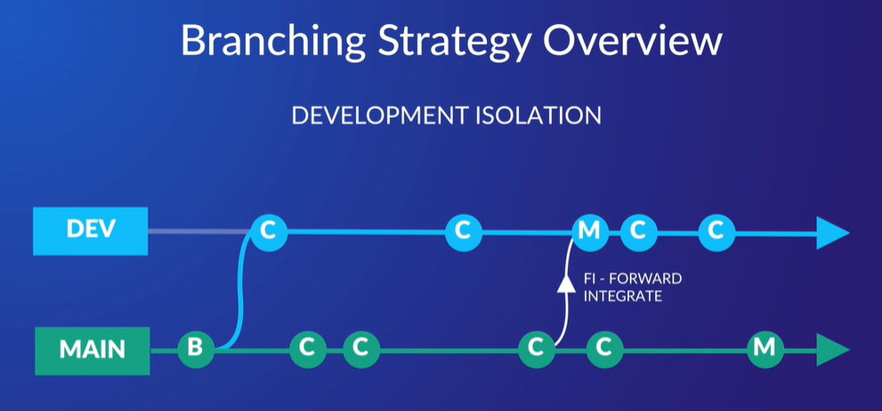
21. 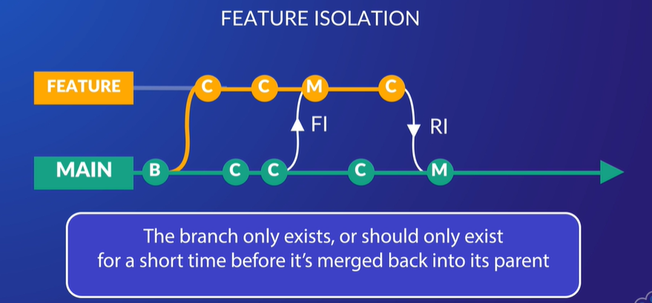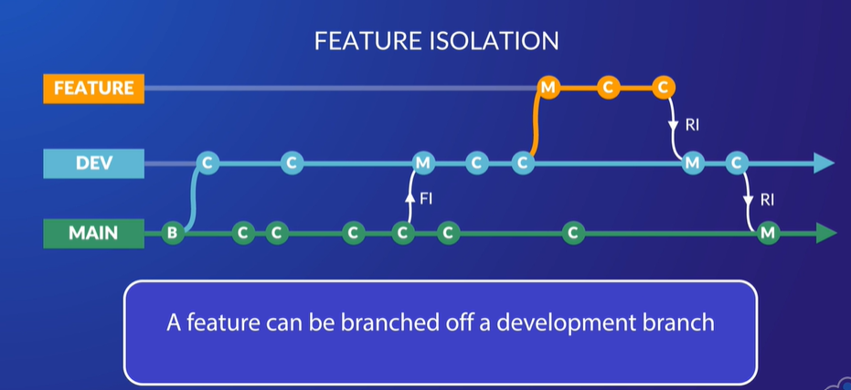
22. 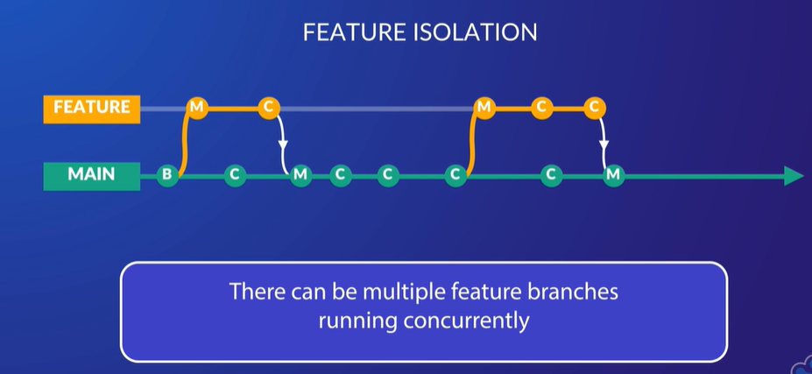
23. <https://www.youtube.com/watch?v=1SXpE08hvGs>
24. Release isolation is geared towards creating multiple production versions of your software as each release branch is a snapshot of the code when the branch is created. Release branches can coexist with development or feature branches. When you want to release a new version of your software because the required features have been completed, tested and merged back into master, you create a release branch. The release branch is read-only, with one exception. If a bug is found in production code, it is fixed in the release branch and merged back into the main branch.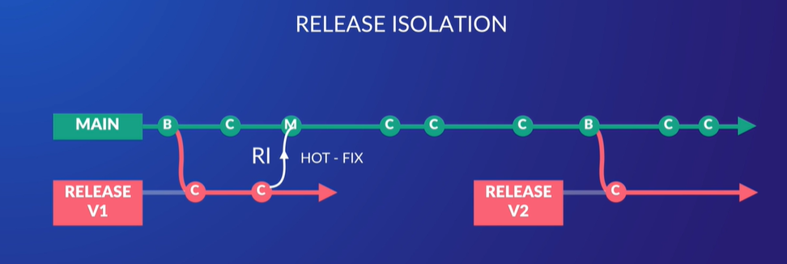
25. GitHub Flow is the archetypal branching strategy, and pretty much what I described in the Got commitment, or should be committed slide. In GitHub flow, the master branch is always deployable and should reflect what is in production. Any new work is created in a branch off master. Regularly commit to that branch locally and push to that branch on the server. When the branch is ready or finished, open a pull request for the code to be reviewed. This can also be done when you need help, feedback, or a second opinion on the code. Once the branch has been reviewed and tested, it can be deployed into production. If the deployed branch causes issues or has bugs, it can be rolled back by deploying the existing master. Otherwise, the branch can be merged with master.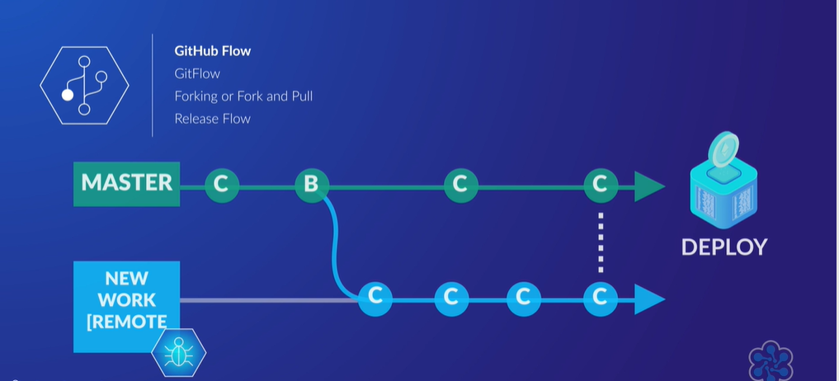
26. we have Gitflow, which has, for all intents and purposes, two main branches. The master branch is stable code that reflects what is deployed in production. The development branch is the parent branch of most code changes. When a change is required, a branch is created from the development branch. These branches can be categorized as feature branches, branched from development merged to development, release branches, branched from development merged to master and development, and hotfix branches, branched from master merged to master and development. A development branch becomes like a master branch for a set of features. When a feature is finished, it is merged back to the development branch. To deploy the new functionality, a release branch is created from the development branch. The release branch, typically named as the release version number, including any bug fixes and tweaks, is merged back into development and master branches after the release is deployed. If a critical bug is discovered in the live application that can't wait for the next release, a hotfix is required. A hotfix is branched off master and merged back into master as well as development, so both code threads get the fix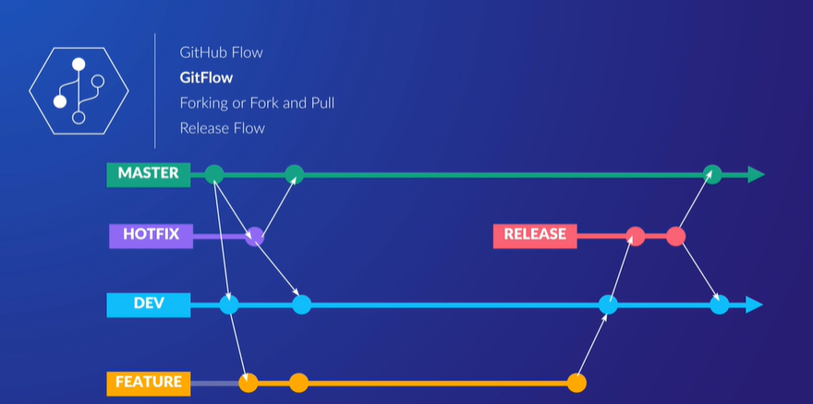
27. Forking, or fork and pull. This strategy is typically found in public projects where you want to use an existing code base as the starting point for your project. A developer will clone the original repository to their own remote repository, creating a new origin master branch. When forking a project, it is implied that you won't be trying to merge your changes back to the original.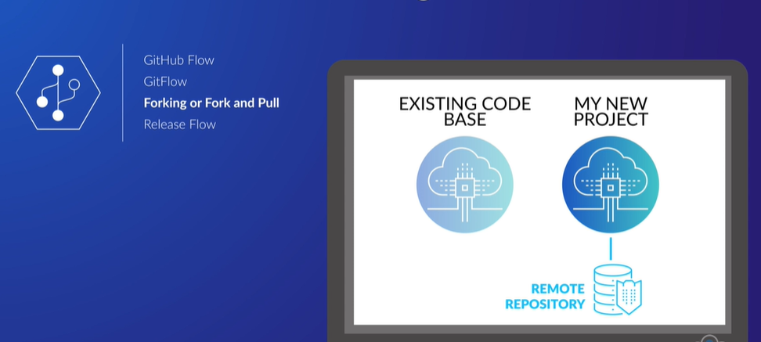
28. Release flow is Azure DevOps' internal take on Trunk Based Development, and where the line between branching strategies and code flow blurs. As the name implies, all branches, be they features, bugs or hotfixes, are branched directly off the master trunk. Where Release Flow diverges from traditional trunk-based models is how and when the code is deployed. This strategy puts emphasis on the release schedule, which is tied to deploying at the end of each sprint. The strategy is designed around workflow, adhering to continuous integration and deployment processes, and projects at scale. In terms of workflow, it fits with the sprint schedule, but the main reason to do this, as the sprints usually don't correspond to any one feature branch, is the time taken to do the actual deployment. There are literally hundreds of developers working on hundreds of branches at any one time. It is totally impractical to have deployments dictated by feature branch completion, as developers would spend too much time waiting for their queued release to be deployed before continuing with the next feature. 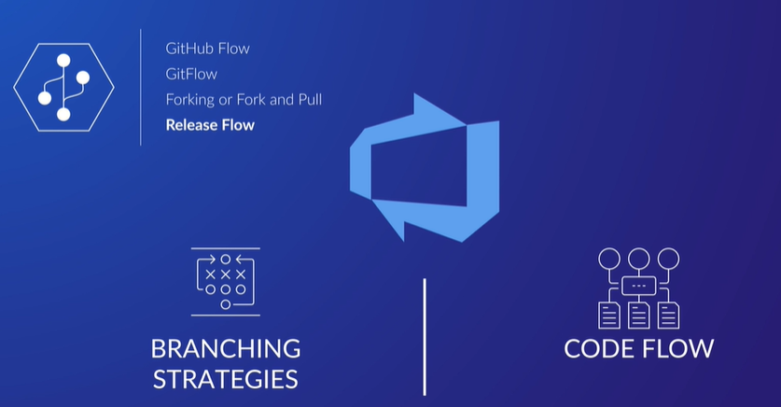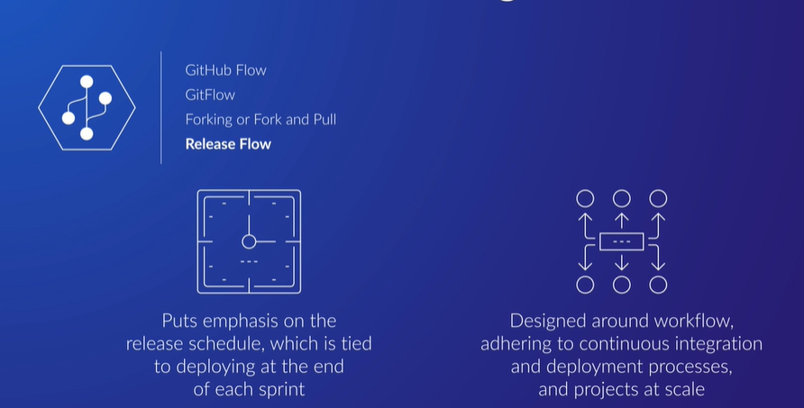
29. <https://www.youtube.com/watch?v=ykZbBD-CmP8>
30. The first issue that comes to mind when looking at this graphic is how does it deal with half-completed features at the time of release deployment? Well, they use feature flags to turn off incomplete functionality within the code. If you are unfamiliar with feature flags, in its most elementary form, it is conditional branching around some code. That is, if the feature is enabled, show it, else don't. It can be a lot more sophisticated in terms of conditions to be evaluated, but that's it in a nutshell. The other issue is hotfixes. These are done on the main branch and then cherry-picked into the release branch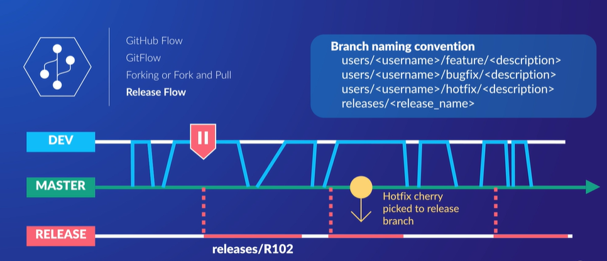
31. The development or topic branches need to be as small as possible, so work is broken down into its smallest logical functional units. This serves two purposes. It makes reviewing and testing much easier and quicker, while limiting damage if something does go wrong. And it's no surprise that testing is very important when merging straight back to the master trunk. Each feature branch is tested as if it was going into production before merging back to master, because in essence, it is.
32. 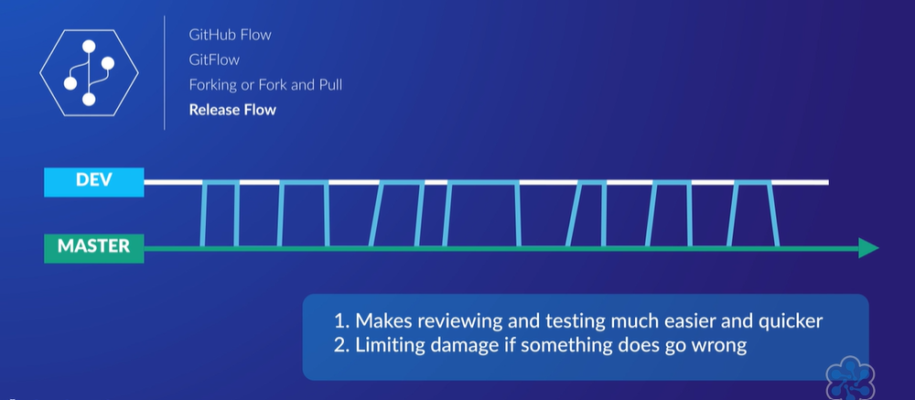
33. **Basic merge** command is for integrating changes from one branch to another, and by default, Azure DevOps uses the git merge command with the no fast-forward option. No fast-forward creates a commit on the target branch of the merge, let's say the main branch when merging a feature branch, and that commit contains the history of commits up to that point, so very helpful in terms of seeing how the development evolved. In contrast, a fast-forward merge is only possible when there is no divergence between the branches. This means there is nothing in the main branch code that isn't in the feature branch
34. 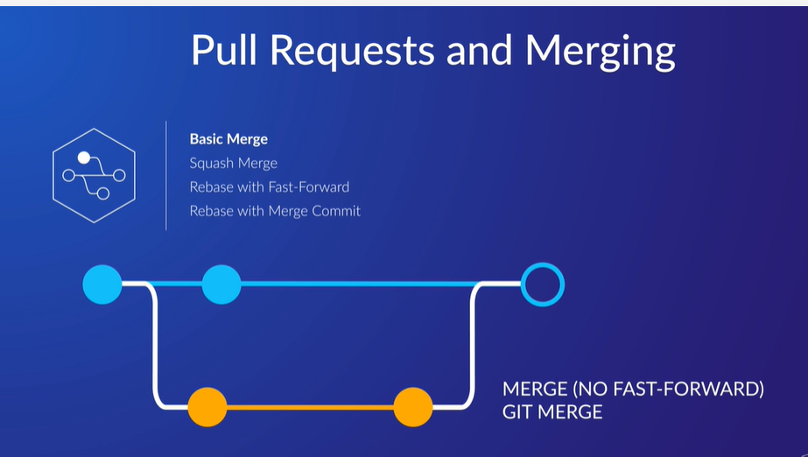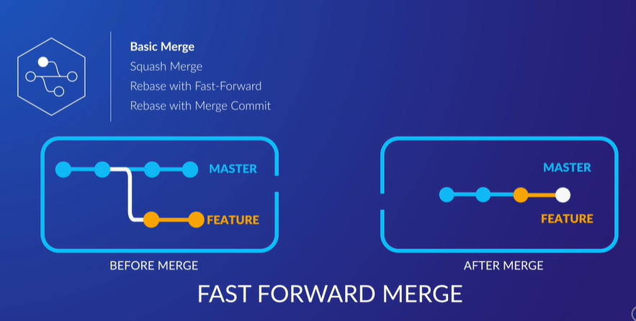
35. A squash merge takes the commits of the branch in question, say a feature branch with three commits, and condenses or squashes the contents of those commits into one commit on the target branch of the merge. In general, commit messages should clearly define the intent of the change and make sense when viewed in isolation, but too often, this isn't the case. The squash merge commit is a way to summarize the intent and function of a branch without all of its commit baggage. As the branch being merged is essentially discarded, the commit history is linear.
36. 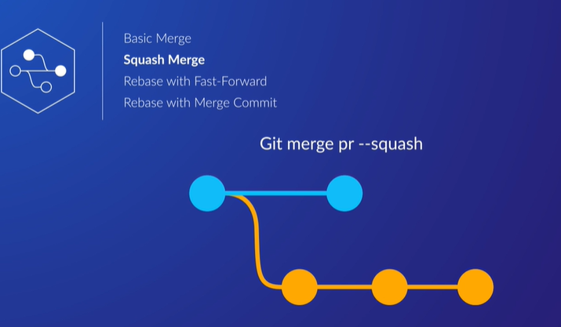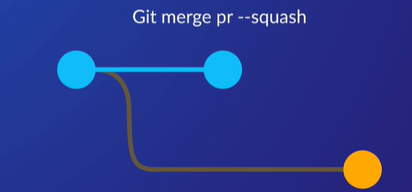
37. Rebasing is taking your branch and repositioning it at the end of its parent branch. Doing this effectively eliminates any divergence between the two branches, so a fast-forward merge can be performed to make the tip of the child branch now the tip of the parent, that is the child becomes an extension of the parent including its commit history. Like squash merge, this keeps the commit history linear, but also preserves individual commits. What rebase is actually doing is blowing away the commits on the branch and adding it back to main branch
38. <https://www.youtube.com/watch?v=f1wnYdLEpgI>
39. 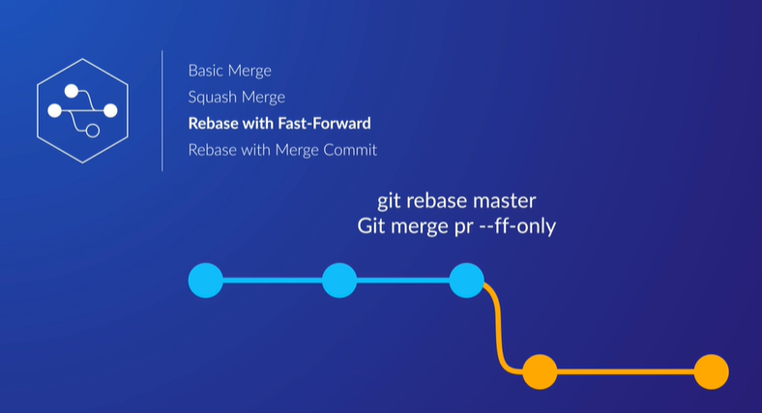
40. Finally, we have rebase with a no fast-forward merge commit. The pull request commits are rebased to the end of the parent branch, then a no fast-forward merge is performed. Fundamentally, this is the same as the rebase with fast-forward merge, except branching and merging are immediately obvious when viewing the development history. 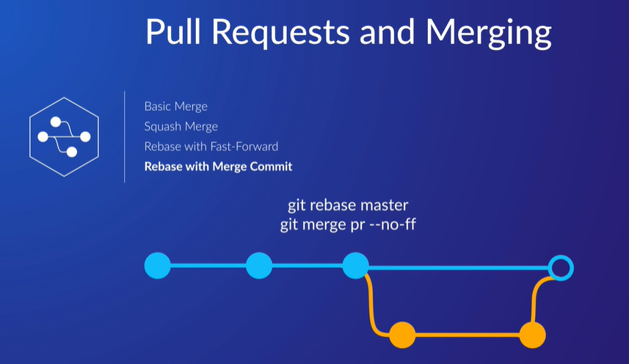
41. Merge preserves the branch history- rebase doesn’t
42. <https://www.youtube.com/watch?v=dO9BtPDIHJ8>
43. <https://www.youtube.com/watch?v=MxncLUOLdAQ>
44. Setting permissions on repos:
45. In a nutshell, centralized systems let you, with differing degrees of ease, set permissions right down to the file level, while distributed systems typically only go as far as the branch.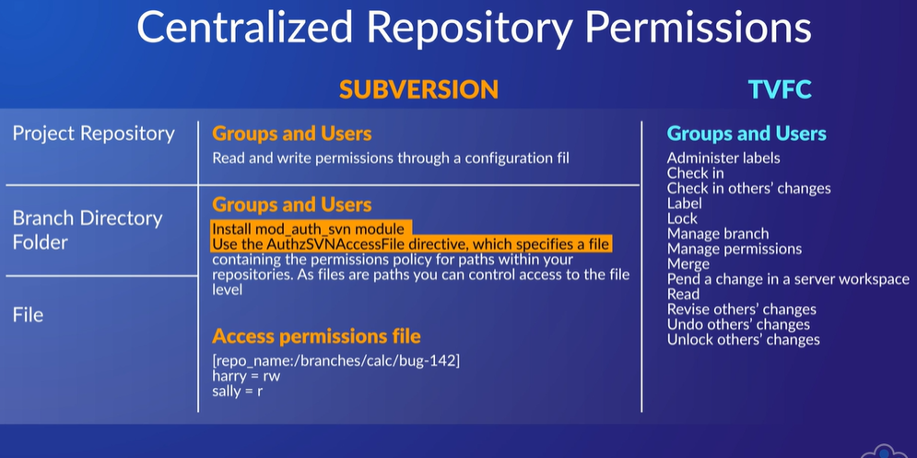
46. The default permissions for these systems is allow access that has access is either allowed or not specified. Azure DevOps actions have two effective permissions, allow and deny, plus not set, Bitbucket Cloud and GitHub Enterprise, both have read, write, and admin in common. GitHub Enterprise also adds triaged permissions for managing issues and pull requests without write access and maintain permission for managing repositories without the ability to access destructive or sensitive actions